Problem Set 6

6SSMN961: APPLIED ECONOMETRICS

1. Use the data provided to estimate the DD model. What type of standard errors are you using and why? Interpret the DD coefficient.

The estimated DD model is in the Stata output. The DD coefficient is equal to -.2065 (𝛿 = -.2065). We are using a Log-Level regression therefore the coefficient should be interpreted as:

$$\%∆y ≈100δ∙ ∆D$$

$$∆y ≈-20.65\%$$

$$∆y=-\left(1-e^{-.2065}\right)∙ 100=-18.66\%$$

The increase in tuition fees reduced the number of applications by 18.66% (p -value < 0.01)

I am using Clustered standard errors to avoid the problem of serial correlation that could appear because we are using panel data. Cluster standard errors guarantees that we do not have to worry about serial correlation which could distort the results.

1. Under what assumption can you interpret the DD estimate from part 1 as the causal effect of the increase in tuition fees on university applications? Use the data to construct a graph that provides a visual check of this identification assumption. What do you conclude from this graph?

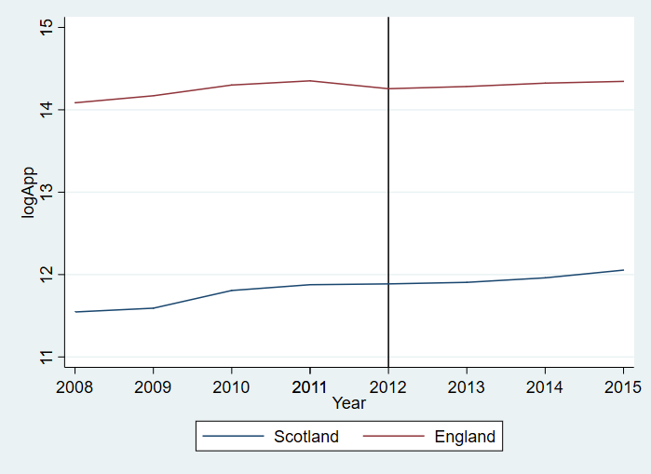

Under the common trend assumption, this implies that treatment and control group followed a common trend before the treatment. If this assumption does not hold up the contrafactual would be wrong hence we would not be able to interpret the coefficient as the causal effect.

Looking to the graph the common trend assumption seems reasonable, the evolution of the applications in England and Scotland drew parallel lines before 2012. Although after the increase in fees we can see a divergence of the common pattern by England. All of this seems to fit the assumptions.

1. Repeat the analysis in part 1 but extend the model to include a country-specific linear trend. How do your results change?

The new DD coefficient is equal to -.2631 (𝛿 = -.2631). which means that in the new model the increase in tuition fees reduced the number of applications by 23.14% (p -value < 0.01)

These results are consistent with the first estimation and support the causal interpretation of the first model DD estimate as the inclusion of state trends do not make a difference.

The results change in a slight quantitative way but no qualitative which is good for the interpretation of the first model and the common trend assumption.

1. To check whether the effect of the increase in tuition fees on applications is different for STEM subjects (science, technology, engineering and mathematics) and non-STEM subjects, the model is modified. Interpret the estimates 𝛿𝑆𝑇𝐸𝑀 and 𝛿𝑁𝑂𝑁−𝑆𝑇𝐸𝑀. What do you conclude about the effect of the increase in tuition fees on applications for different types of subjects?

(𝛿𝑆𝑇𝐸𝑀 = -.0993) The increase in tuition fees caused a 9.46% decrease on the number of applications for STEM subjects. (p -value < 0.01)

(𝛿𝑁𝑂𝑁−𝑆𝑇𝐸𝑀 = -.2788) The increase in tuition fees caused a 24.33% decrease on the number of applications for STEM subjects. (p -value < 0.01)

There is a substantial difference between the drop on these two categories. It can be said that applications to STEM subjects are less sensible to the increase in fees than non-STEM ones.

5. To check whether the increase in tuition fees affects applications differently depending on the expected salary after graduation, the model is modified. Interpret the estimates 𝛿1,𝛿2,𝛿3 and 𝛿4. Does the effect of the increase in tuition fees on applications depend on the expected salary after graduation?

(𝛿1 = -.2476)

(𝛿2 = -.2462)

(𝛿3 = -.2225)

(𝛿4 = -.1143)